GLENROTHES ART CLUB (SCIO)
Caledonia House
Pentland Park
Saltire Centre
Glenrothes
KY6 2AL

Tel: 01592 56 21 09
Email: glenrothesartclub@gmail.com
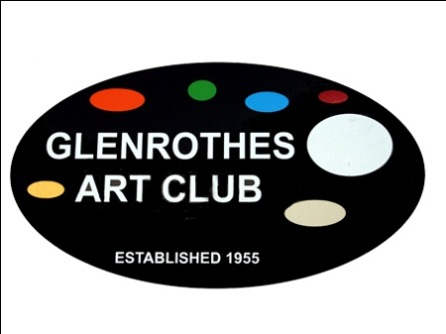

NON-MEMBERS POLICY

- Introduction

Glenrothes Art Club is a Scottish Charitable Incorporated Organisation encouraging and facilitating the practice of arts and crafts.

2. Non- Members
It is the policy of Glenrothes Art Club to allow all people interested in attending the club to come along for a period of approximately 1 month to participate in activities, before being expected to join the club as Members. However, we need to keep a register of all non-members using the club studios and taking part in activities. This allows the Club to make contact regarding what is happening in the club i.e. classes and workshops and also have a register for health and safety.

If you are not yet a Member we would ask you to complete a membership form as soon as possible. The cost will be determined at the Annual General Meeting. Membership fees become due at the AGM and can be payable in 2 parts, as determined by the Board..

This does not apply to members of the public who come to a workshop as a one-off. Their attendance assists the financial costs and makes workshops a better price for all taking part.
For non-members attending Classes, Courses and Workshops, the fee payable will be advertised for each event.

A “Register of Non-members Form” requires to be completed with your details.

Signed:...................................................................... (on Behalf of Board of Management)

Date:..........................................

Review date:…………………………….…….

Visit our website: www.glenrothesartclub.org.uk
Facebook: Glenrothes Art Club
Twitter: @GlenrothArtClub

