GLENROTHES ART CLUB (SCIO)
Caledonia House
Pentland Park
Saltire Centre
Glenrothes
KY6 2AL

Tel: 01592 56 21 09
Email: glenrothesartclub@gmail.com
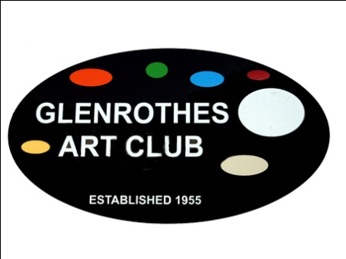

DATA PROTECTION POLICY

- Introduction

Policy Statement

Glenrothes Art Club is a Scottish Charitable Incorporated Organisation encouraging and facilitating the practice of arts and crafts.

This policy applies to the Board, members, and users of Glenrothes Art Club.

All data/information processed by the organisation is covered by this policy.

The organisation holds personal data about you and the Data Protection Act 1998 and subsequent updates protects people against the misuse of personal data and covers both manual and electronic records.

The Act requires that any personal data held should be:
- processed fairly and lawfully.
- obtained and processed only for specified and lawful purposes.
- adequate, relevant and not excessive.
- accurate and kept up to date.
- held securely and for no longer than is necessary; and
- not transferred to a country outside the European Economic Area unless there is an adequate level of data protection in that country.

- Purposes for Which Personal Data may be Held
Personal data relating to people may be collected primarily for the purposes of:
- Keeping proper membership records
- Keeping proper records of attendance at Art Club sessions, courses, classes and events
- Communicating with members and users

The organisation considers that the following personal data falls within the categories set out above:
- personal details including name, address, telephone numbers, email addresses, age, membership status.
- emergency contact details.

The organisation will review the nature of the information being collected and held on an annual basis to ensure there is a sound reason for requiring the information to be retained.

- Responsibility for the Processing of Personal Data
The organisation’s Data Controller is the Secretary of the Board who is responsible for ensuring all personal data is controlled in compliance with the Data Protection Act 1998.

All members who have access to personal data must comply with this Policy and adhere to the procedures laid down by the Data Controller. Failure to comply with the Policy and procedures may result in disciplinary action.

- Use of Personal Data
To ensure compliance with the Data Protection Act 1998 and in the interests of privacy, confidence and good relations, the disclosure and use of information held by the organisation is governed by the following conditions:
- personal data must only be used for one or more of the purposes specified in this Policy.
- documents may only be used in accordance with the statement within each document stating its intended use; and
- provided that the identification of the individual members and users is not disclosed, aggregate or statistical information may be used to respond to any legitimate internal or external requests for data (e.g., surveys, membership level figures); and
- personal data must not be disclosed, either within or outside the organisation, to any unauthorised recipient.

- Personal Data Held for Equal Opportunities Monitoring Purposes
Where personal data obtained about people is to be held for the purpose of Equal Opportunities monitoring, all such data must be made anonymous.

- Disclosure of Personal Data
Personal data may only be disclosed outside the organisation with the employee’s written consent, where disclosure is required by law or where there is immediate danger to the employee’s health.

- Accuracy of Personal Data
The organisation will review personal data regularly to ensure that it is accurate, relevant and up to date.

In order to ensure that our files are accurate and up to date, and so that the organisation is able to contact the member or user or, in the case of an emergency, members must notify the Secretary of Glenrothes Art Club as soon as possible of any change in their personal details (e.g., change of name, address; telephone number, etc).

- Access to Personal Data (“Subject Access Requests”)
Members have the right to access personal data held about them. The Secretary of Glenrothes Art Club will arrange for the member to see all personal data held about them within 21 days of receipt of a written request.

- Retention of records.
The organisation will retain personal records for no longer than five years after a person has ceased to be a member of Glenrothes Art Club.

- Related Policies
Equal Opportunities Policy

Implementation Date: _____________________

Review Date: ___________________________

Signed: ________________________________
(for and on behalf of the Board)

Visit our website: www.glenrothesartclub.org.uk
Facebook: Glenrothes Art Club
Twitter: @GlenrothArtClub

